Mission Statement  The Bayview IMANI Breast Cancer Support Group was founded in October 2001 because there was a greater need for more specific attention to be placed on breast cancer survivors in the communities of Bayview Hunter’s Point, Potrero Hill, Visitacion Valley and Sunnydale. The primary focus is to provide information on breast health and nutrition, but also offer an open forum as a support group to address other health disparities like diabetes and hypertension that are plaguing low-income, underserved African-American women. Hence, this organization was developed to embody all survivors by addressing their fears and concerns surrounding breast cancer. The Support Group, a local support unit, meets every third Wednesday of the month. Women can find comfort, feel safe, gather information and understand they are not alone in the fight against breast cancer. They are also given the opportunity to plan fundraisers, special events and help encourage other survivors to participate. |  |  | Bayview IMANI Breast Cancer Support Group  P.O. Box 34511  San Francisco, CA 94134 |  |  | Bayview IMANI  Breast Cancer Support Group  - “Women Working Together for a Healthier Community”  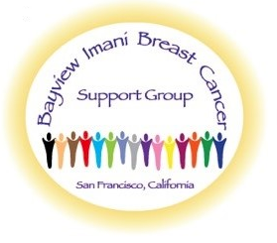

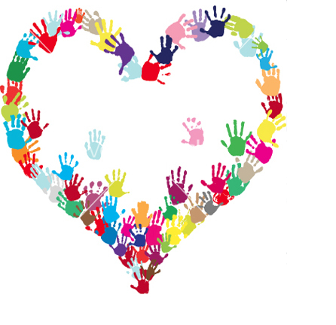  Annual Event  Every year, the Bayview IMANI Breast Cancer Support Group honors women who have survived breast cancer as well as those who continue fighting the battle. We also pay homage to the fallen angels who have succumbed to the disease.  Every October, for Breast Cancer Awareness Month, we provide a luncheon at a local community facility. Additionally, we invite guest speakers to dialogue about breast cancer early detection and intervention, genetic and environmental risk factors, breakthrough treatments, and a variety of lifestyle topics of interest to the public.  For more information about what we do, please contact us! |  |  | Breast Cancer Facts  From nationalbreastcancer.org  What is Breast Cancer?  Breast cancer is a disease in which malignant (cancer) cells form in the tissues of the breast. The damaged cells can invade surrounding tissue, but with early detection and treatment, most people continue a normal life.  Facts about Breast Cancer in the U.S.  - One in eight women will be diagnosed with breast cancer in their lifetime.  - Breast cancer is the most commonly diagnosed cancer in women.  - Breast cancer is the second leading cause of death among women.  - Each year it is estimated that over 220,000 women in the United States will be diagnosed with breast cancer and more than 40,000 will die.  - Although breast cancer in men is rare, an estimated 2,150 men will be diagnosed with breast cancer and approximately 410 will die each year.  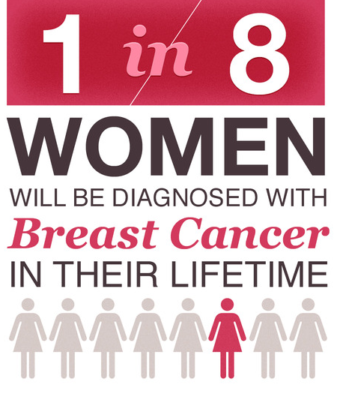 |  |  | What We Do  The Bayview IMANI Breast Cancer Support Group puts itself out there to offer breast health information and materials to aid in Breaking the Silence about breast cancer by using breast cancer survivors, volunteers and community residents. We connect as a means of accomplishing outreach in the four underserved areas of Bayview Hunter’s Point, Potrero Hill, Visitacion Valley and Sunnydale. Women, and some men, receive educational materials in privacy as well as being shown breast self-examinations using breast models. This helps raise awareness and drives home the importance of early detection, breast self-examinations and scheduling regular mammograms.  Contact Us  Bayview IMANI Breast Cancer Support Group  P.O. Box 34511  San Francisco, CA 94134  415.748.2762  bayviewimanibcsg@icloud.com  www.bayviewimani.org
BOARD OF DIRECTORS – Founder: Kathryn J. Summers, RN, MSN ∞ Vice President, Laura Barber ∞ Secretary, Antionetta McFarland
Ola Donley, Financial Secretary ∞ Jovita Abriam, Treasurer

